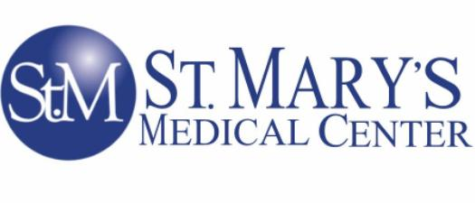
Declination COVID-19 Vaccination

PLEASE PRINT CLEARLY
Name (Last, First, MI):
Department: Job Title:
Employee Number: Date of Birth:

St Mary’s Medical Center recommends that I receive COVID-19 vaccination to protect myself, patients, staff, and others in the healthcare facility.

I acknowledge that I am aware of the following facts (read and initial each line):

COVID-19 is a disease caused by a virus named SARS-CoV-2. It most often causes respiratory symptoms but may attack more than my lungs and respiratory system. Over one million people have died from COVID-19 in the United States (CDC, July 10, 2023).

COVID-19 vaccination is recommended for me and all other healthcare workers to protect myself, our staff and our facility’s patients from COVID-19, its complications, and death.

If I become infected with COVID-19 I can spread it to others, even if my symptoms are mild or I have no symptoms. Symptoms that are mild or non-existent in me can cause serious illness and death in others.

What do I do if I have COVID-19 exposure, symptoms or positive test?
All healthcare workers are required to call Employee Health for COVID-19 exposure, symptoms and/or positive test. The Employee Health staff will assess healthcare workers over the phone and provide guidance on quarantine, isolation and testing during regular operating hours. Healthcare workers should leave a voice mail message after hours; the call will be returned on the next business day. Symptomatic or positive healthcare workers should not report to work.

I understand that I can change my mind at any time and receive the COVID-19 vaccination at a facility of my choice and provide appropriate documentation to Employee Health, assigned supervisor and/or contract management system.

I have read and fully understand the information on this declination form.

Signature Date

Adopted: 8/14/2023

